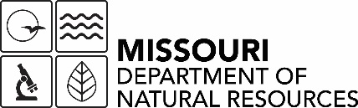

Rulemaking Report
10 CSR 23-4.060 Construction Standards for Monitoring Wells

Pursuant to Section 536.016, RSMo., an agency shall promulgate rules based upon substantial evidence on record. The following information identifies the necessity for the Missouri Department of Natural Resources to propose this rulemaking.

- What is the purpose of the rulemaking and why is it necessary?
The purpose of this rulemaking is to improve rule clarity, correct erroneous citations, and to correct references to ASTM standards. The rulemaking is necessary to ensure the accuracy and clarity of the rule and to ensure the rule is compliant with the administrative requirements in Chapter 536, RSMo.

- What does the rulemaking require and how does it produce benefits?
This rulemaking does not add any new requirements but removes unnecessary language and corrects a regulatory citation benefiting both the Department and the drilling industry by adding clarity to the rule.

- Who has or will be involved in the development of the rulemaking?
The Department, the Well Installation Board, stakeholders, citizens, and other organizations will have the opportunity to comment on the proposed amendments.

- Who may I contact to either ask questions or provide input on this rulemaking?
Brad Mitchell of the Department’s Geological Survey Program at 573-368-2116, in writing at P.O. Box 250, Rolla, MO 65402, or via email at brad.mitchell@dnr.mo.gov; or Michelle Oglesby, (573) 368-2165, michelle.oglesby@dnr.mo.gov

- What is the tentative schedule for this rulemaking (in particular the comment period and public hearing)?
We anticipate completion of draft rule language and rulemaking report October 14, 2022, program review February 1, 2023, Division request to begin rulemaking March 1, 2023, stakeholder meetings complete by May 1, 2023, public notice, comment period, and hearing fall 2023, rule effective spring 2024.

